iDempiere OutSourcing Production (Active)

Brief Description of the whole process :

Description of the Main Process.

SALES ORDER

a ) MATERIAL RECEIPT of the RAWBOX ( copy of the standard MAterial receipt ) but

Preface : as we need to manage workflow we need : LIBERO MANUFACTURING

**DataSet**

Uom :

Square Meters UOM CODE : “SQ” symbol =”sq” Name Square meter Tipo Area

Price List :

Listino Outsourcing issalespricelist

*Product :*

Material

-ROWBOX width 300 height 300

-FINISHEDBOX isbom with component ROWBOX qty 1

Activities

W-Painting UOM square meters Tipo Service Price 2 €

W-Drilling UOM each Tipo Service Price 3 €

W-Assembly UOM each Tipo Service Price 5 €

Manu

# 1.Brief Description of the whole process :

Out Customer tell us to make some activites like (P) painting, (D) drilling and (A) assembling on a certain row good (ROWBOX) that he has already sent us or he will send us , or he is sending the goods right now (together with the order) .

We need to accept the row goods (ROWBOX) . and send BACK the FINISHEDBOX when we have finished the process.

Activities of Painting are be paid in 2 € for SQ (square meters ) calculate on the ROWBOX

Activities of Drilling are be paid in 3 € each and there are 4 for each ROWBOX

Activity of Assembly are be paid in 5 € each and there are 1 for each ROWBOX

There is a Bom the know the components of the BOXFINISHED

The Order is to produce the FINISHEDBOX . sometime the components should change. And Some times we use OUR components SO WE NEED TO SELL THEM TO THE CUSTOMER .

We need also to trace the inventor movement :

Row good from the customer to an external warehouse (+1 RAWBOX)

Row goos Waiting for production ( -1 RAWBOX +1 RAWBOX)

Consume the row goods and declare the finished product (-1 RAWBOX +1 BOXFINISCHED)

Send the good to the customer. -1 BOXFINISHED



# 2. Description of the Main Process.

**Before** the production process there is a Contract between the customer and the company (vendor) . This contract is a price list for the activities (painting,drilling..) to be done.

The pricelist refer to product , that are referred to activities on one or more Workflow.

Example :

**Activity** -> Product : Drilling , Painting and Assembly

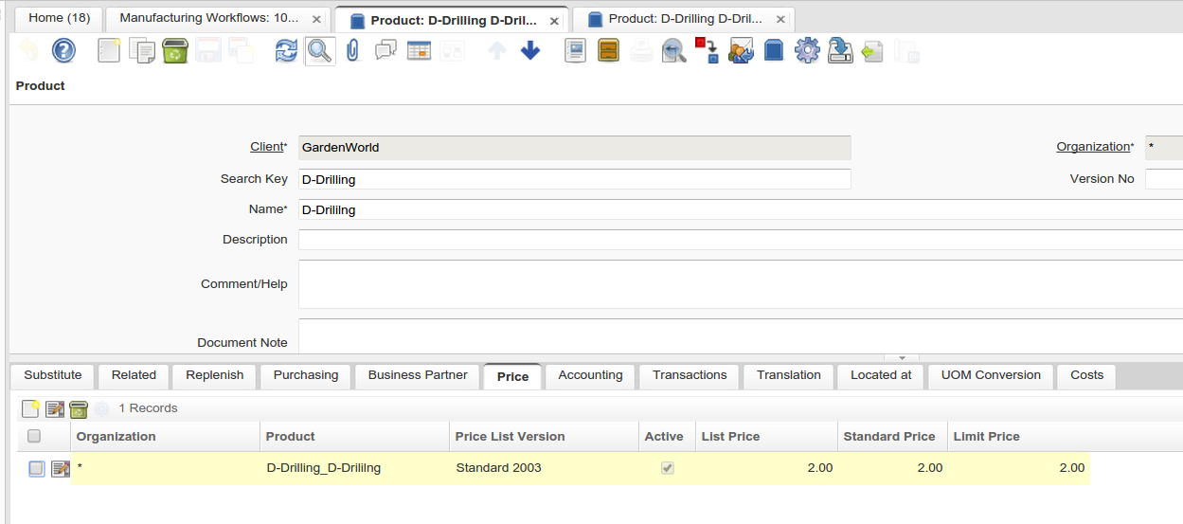

The Price List must be managed (as standard from)

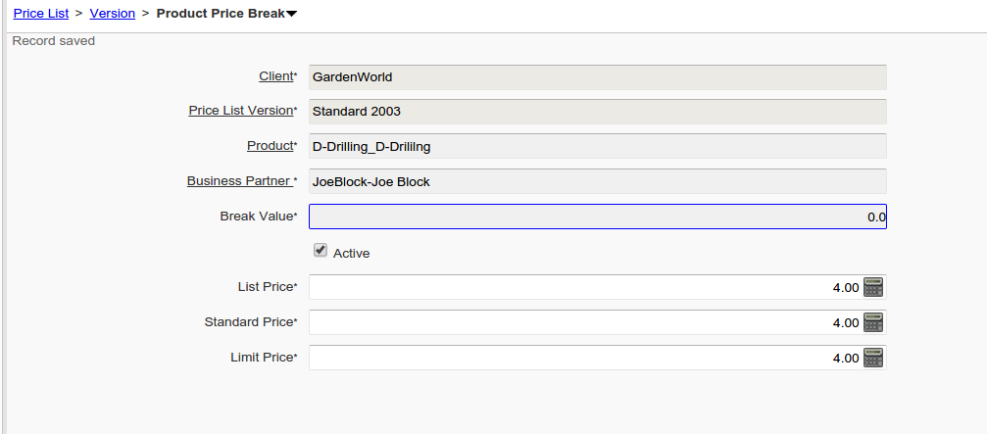

WORKFLOW (a set of activities )

In this example we have a workflow of 3 activities : Painting, Drilling and Assembling

We have 2 activities as we don’t want to manage Drilling alone .

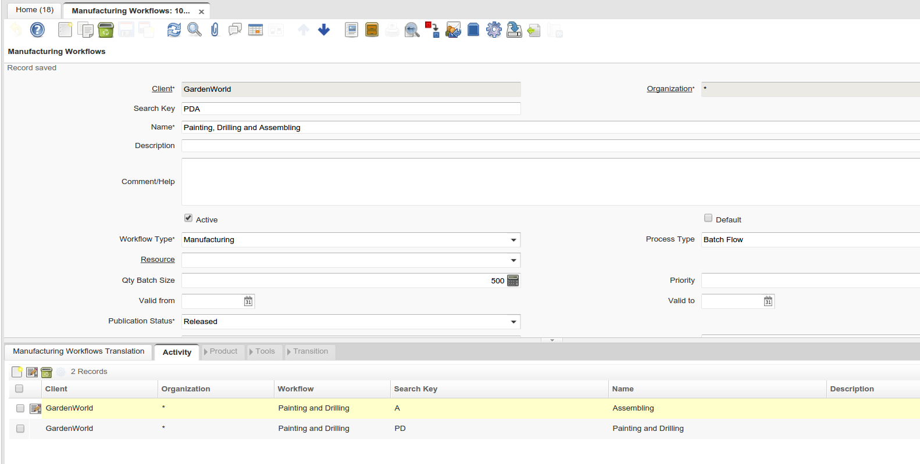

Each Activities has one or more product

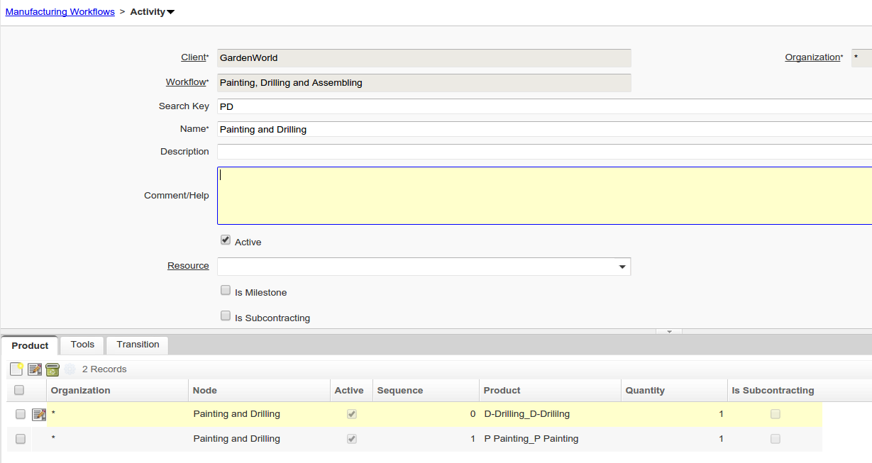

# SALES ORDER

as everything start from the sales order we need to adapt the sales order to the new process. ( Copy of the Sales Order to Sales Order Outsourced Production (active)

The Header is equal to the standard Sales Order

The idea is to add a TAB to manage the finished product

Table : LIT_C_OrderLine_OutProd

This Tab contain : The finish product : BOXFINISHED and the WORKFLOW (PDA)

After Save :

example AntinaFinitRossaTonda300x300

1. ha una db ? se si eplodo (vado al punto …)
2. non ha una db … ha una prodotto related ? no - non faccio niente (mess : no db found)
3. ha una related risaldo al codice related : Antina FinitaModello
4. esplodo la db (componenti ) + misure di Antinafinitamoduello in LIT_c_order_bom

in questo esempio ripoto Antiga grezza

e) se non trovo il workflow di antinafinitamodello messaggio: workflow non trovato )

f) se trovo workflow : partendo dal workflow del prodotto antinafinitamodello esplodo fino a trovare i prodottti di lavorazione (painting,drilling, assembling ) e li esplodo nell orderline

Se modifico il campo workflow :

1. se già valorizzato cancello le righe nelle c_orderline (legate ) ATTEN + prodotti !!
2. se no vedi punto f della voce precedente.

it explode the BOM of the BOXFINISHED into RAWBOX in the TAB

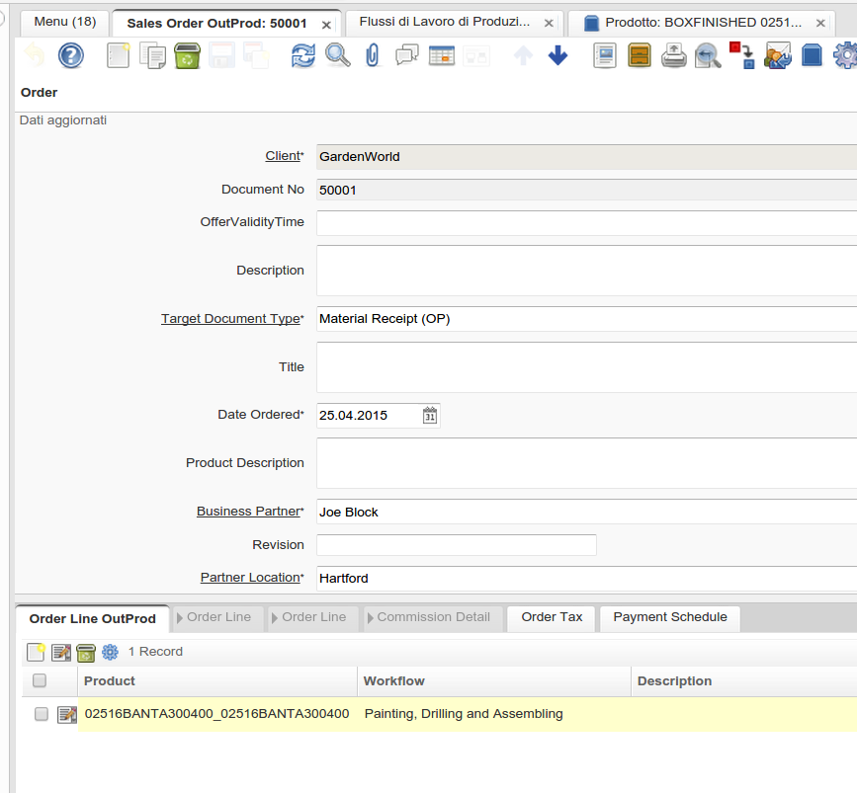

The standard TAB Order Line will contain the activities : to be invoiced . with the correct price.

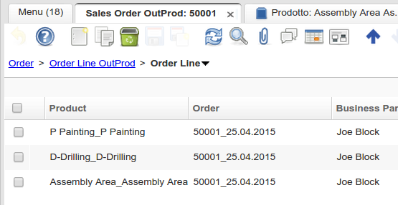

Another TAB LIT_C_OrderLine_BOM (same leve as Order Line ) linked the the LIT_C_OrderLine_OutProd contain the BOM Drop of ht eBOXFINSHED .

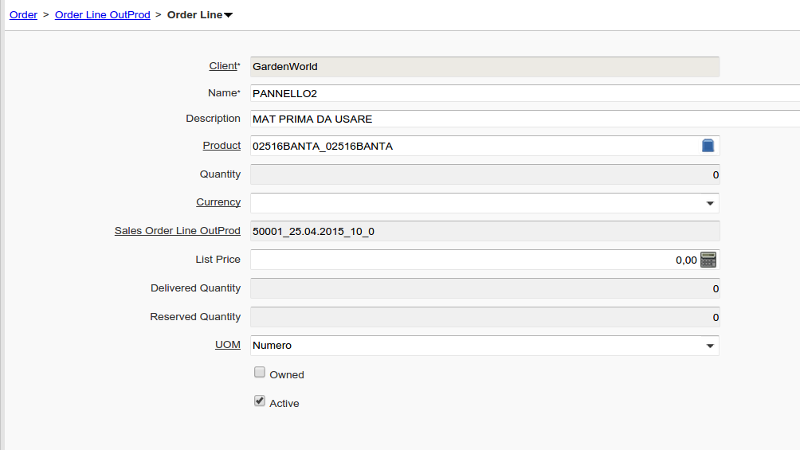

(THE RAWBOX)

Now almost everything is ready …

the order line should be something like this

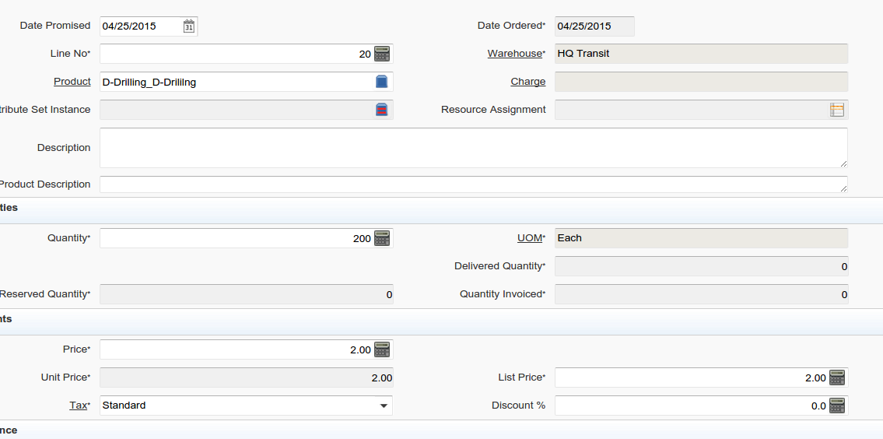

**CASE B - SIZES (PRICELISTTYPE = PLAR)**

**NEW FIELDS : Table : M_Product : LIT_Width , Height, Depth (UOM of AD_ClientInfo.C_UOM_Length_ID**

**NEW FIELD on lit_c_orderline_outprod Width , Height, Depth (UOM of AD_ClientInfo.C_UOM_Length_ID**

**WE NEED WICH UOM MUST REFERENCE TO THIS LOGIC ..**

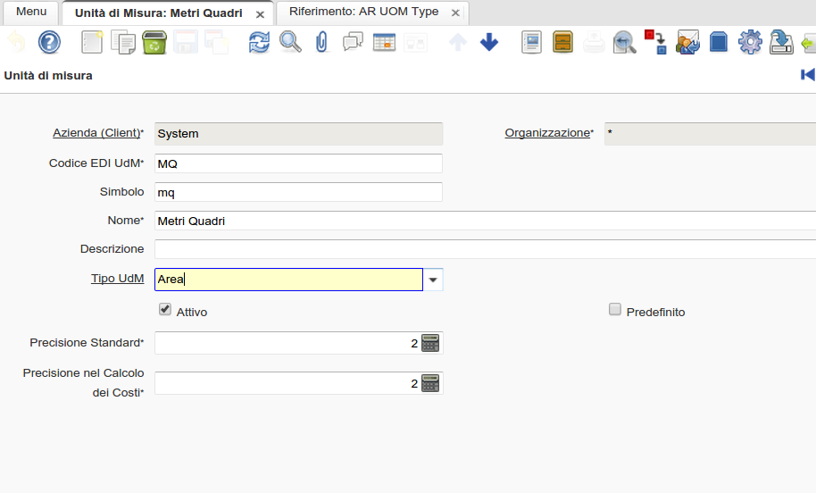

**New Reference LIST : PRICELISTTYPE**

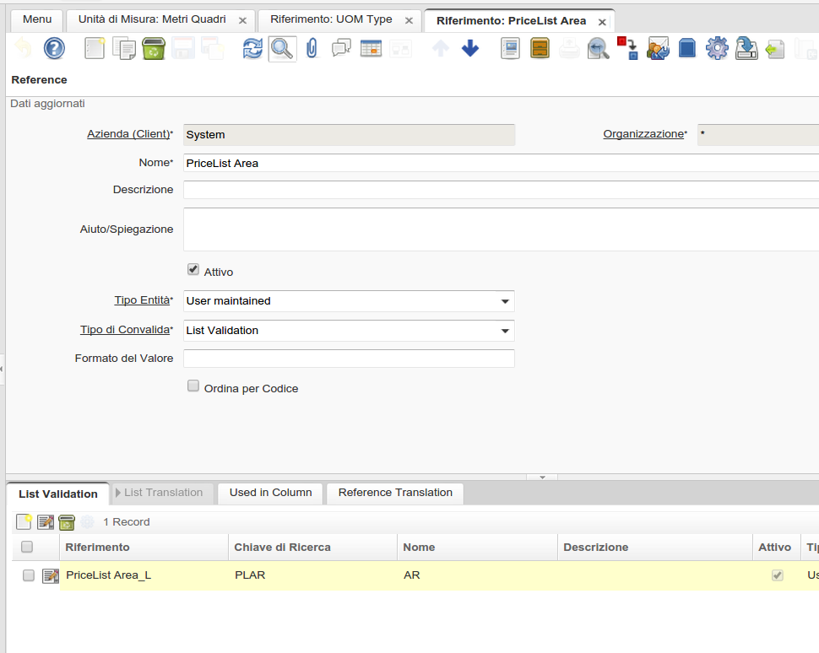

**So if we will use for future needs / uom different from AR almost is adone.**

**OUTSOURCE LINE**

**ANTA (mm) 300x500 = 0,15 mq x 3,5 € = 0,0525 € pieces**

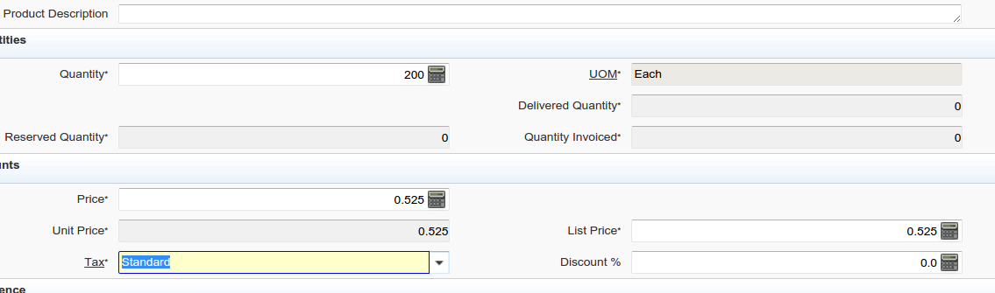

# a ) MATERIAL RECEIPT of the RAWBOX ( copy of the standard MAterial receipt ) but

referred to the LIT_C_OrderLine_BOM

Starting from Material Receipt have a new Process “Create lines from Outsourcing Production”

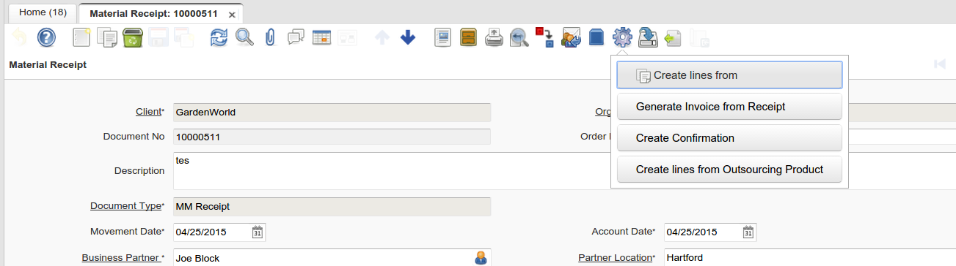

will open “a copy” of the standard “Copy lines from”

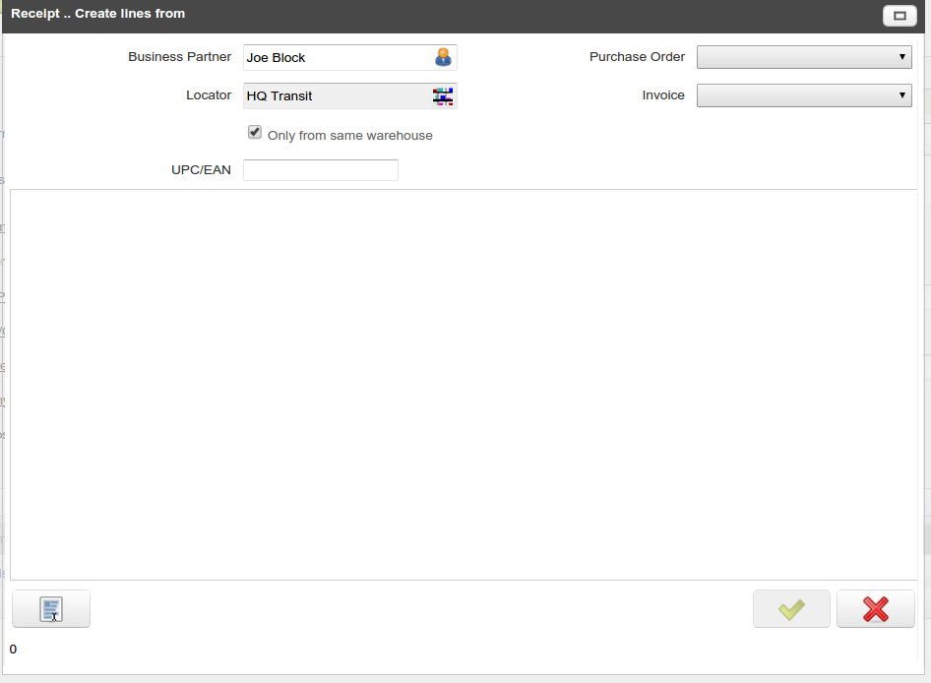

Purchase Order -> OutSourcing Production Order

Invoice : “we don’t need

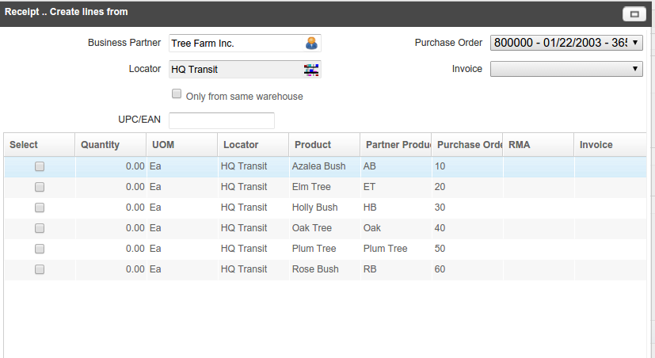

The goods received are not owned by the company ( We have to manage in

ADD a FIELD isowned (better name proposal ?) on the warehouse Table M_Warehouse

WAREHOUSE : MC1 : Customer Warehouse

The good receipt must not have POSTING FACT as they are external movement .

# b) Create the Production Order Yes - Manage the Completation of the order (inventory move ..)

# c) Create the Invoice (more or less… is ready as it is standard)

we try to use the nomal process (from order )

# d) Create the SHIPMENT of the FINISHEDBOXStandard

Create shipment of the FINISHED PRODUCT ( m-inout)